Welcome to Odense for the Nordic IOM meeting 2024

Dear everyone. We look forward to seeing you in Odense on the 25-26th of April 2024, where we hope to be able to have 2 days with interesting talks and exchanges of knowledge and ideas.

The meeting will take place at Comwell H.C. Andersen Odense Dolce by Wyndham, Claus Bergs Gade 7, 5000 Odense, where it will also be possible for you to stay. There are a limited number of hotel rooms, which will be reserved on a first come first serve basis.

For those of you arriving abroad there are direct trains from Copenhagen airport (Kastrup) to Odense central train station (Odense banegård center). From there, it is a 600m walk to Comwell H.C. Andersen Odense.

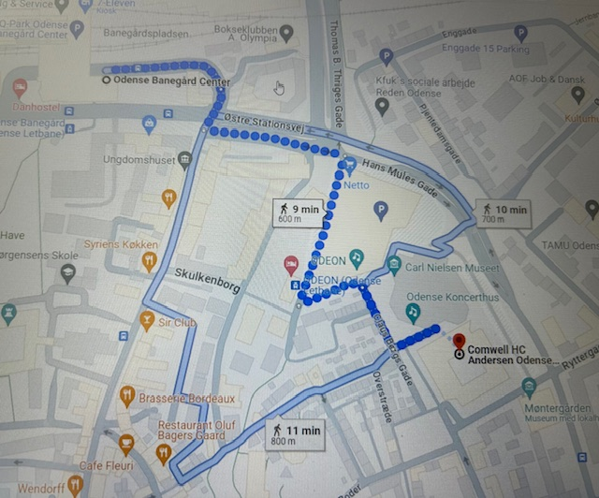

Alternatively, you can take the tram (letbane) right outside of the train station to the stop “Odeon” which is 150m from the hotel.

If you wish to stay somewhere else or if there are no rooms available, other hotels nearby include: CABINN Hotel Odense, First Hotel Grand or Milling Hotel Plaza.

On the last day, there is lunch at the restaurant or the possibility of getting a Sandwich to-go, for those who might be in a hurry to catch a train. Please indicate on the registration form if you would like the “sandwich to-go” option.

To register, please fill in the registration document (Tilmeldingsblanket) and mark whether you also wish accommodation for 1 or 2 nights. Then please send a PDF-copy as an attachment in an email to: stefanie.binzer@rsyd.dk. In the subject please write ”registrering IOM 2024”

If you have any questions please feel free to contact me on [Stefanie.binzer@rsyd.dk](mailto:Stefanie.binzer@rsyd.dk)

We look forward to welcome you in Odense.

Best regards,

Stefanie Binzer